**Experiment 9**

**AIM**: Implement an application that creates an alert upon receiving a message

**MainActivity.java**

package com.example.lab9_notification;

import androidx.appcompat.app.AppCompatActivity;

import android.app.NotificationManager;

import android.app.PendingIntent;

import android.content.Intent;

import android.os.Bundle;

import android.widget.EditText;

import android.widget.Toast;

public class MainActivity extends AppCompatActivity {

NotificationManager notificationManager;

@Override

protected void onCreate(Bundle savedInstanceState) {

super.onCreate(savedInstanceState);

setContentView(R.layout.activity_main);

notificationManager = (NotificationManager) MainActivity.this.getSystemService(NOTIFICATION_SERVICE); }

public void sendNotification(View view) {

String contentText = ((EditText) findViewById(R.id.et)).getText().toString();

if (contentText.isEmpty()) { Toast.makeText(MainActivity.this, "Please enter some text!", Toast.LENGTH_LONG).show(); return; }

Intent contentIntent = new Intent(MainActivity.this, MainActivity.class);

PendingIntent contentPendingIntent = PendingIntent.getActivity(this, 0, contentIntent, PendingIntent.FLAG_ONE_SHOT);

NotificationCompat.Builder builder = new NotificationCompat.Builder(MainActivity.this, "channel_id")

.setSmallIcon(R.drawable.ic_launcher_foreground)

.setContentTitle("Sample Notification")

.setContentText(contentText)

.setContentIntent(contentPendingIntent)

.setPriority(NotificationCompat.PRIORITY_HIGH)

.setAutoCancel(true);

notificationManager.notify(notificationId, builder.build());

}

}

**activity_main.xml**

<?xml version="1.0" encoding="utf-8"?>

<RelativeLayout xmlns:android="http://schemas.android.com/apk/res/android"

android:layout_width="match_parent" android:layout_height="match_parent">

<EditText android:id="@+id/et" android:layout_width="match_parent" android:layout_height="wrap_content" android:hint="Enter text to send in notification"/>

<Button android:layout_width="match_parent" android:layout_height="wrap_content" android:onClick="sendNotification" android:layout_alignParentBottom="true" android:text="Notify Me" android:background="#2d2" android:textSize="32sp"/>

</RelativeLayout>

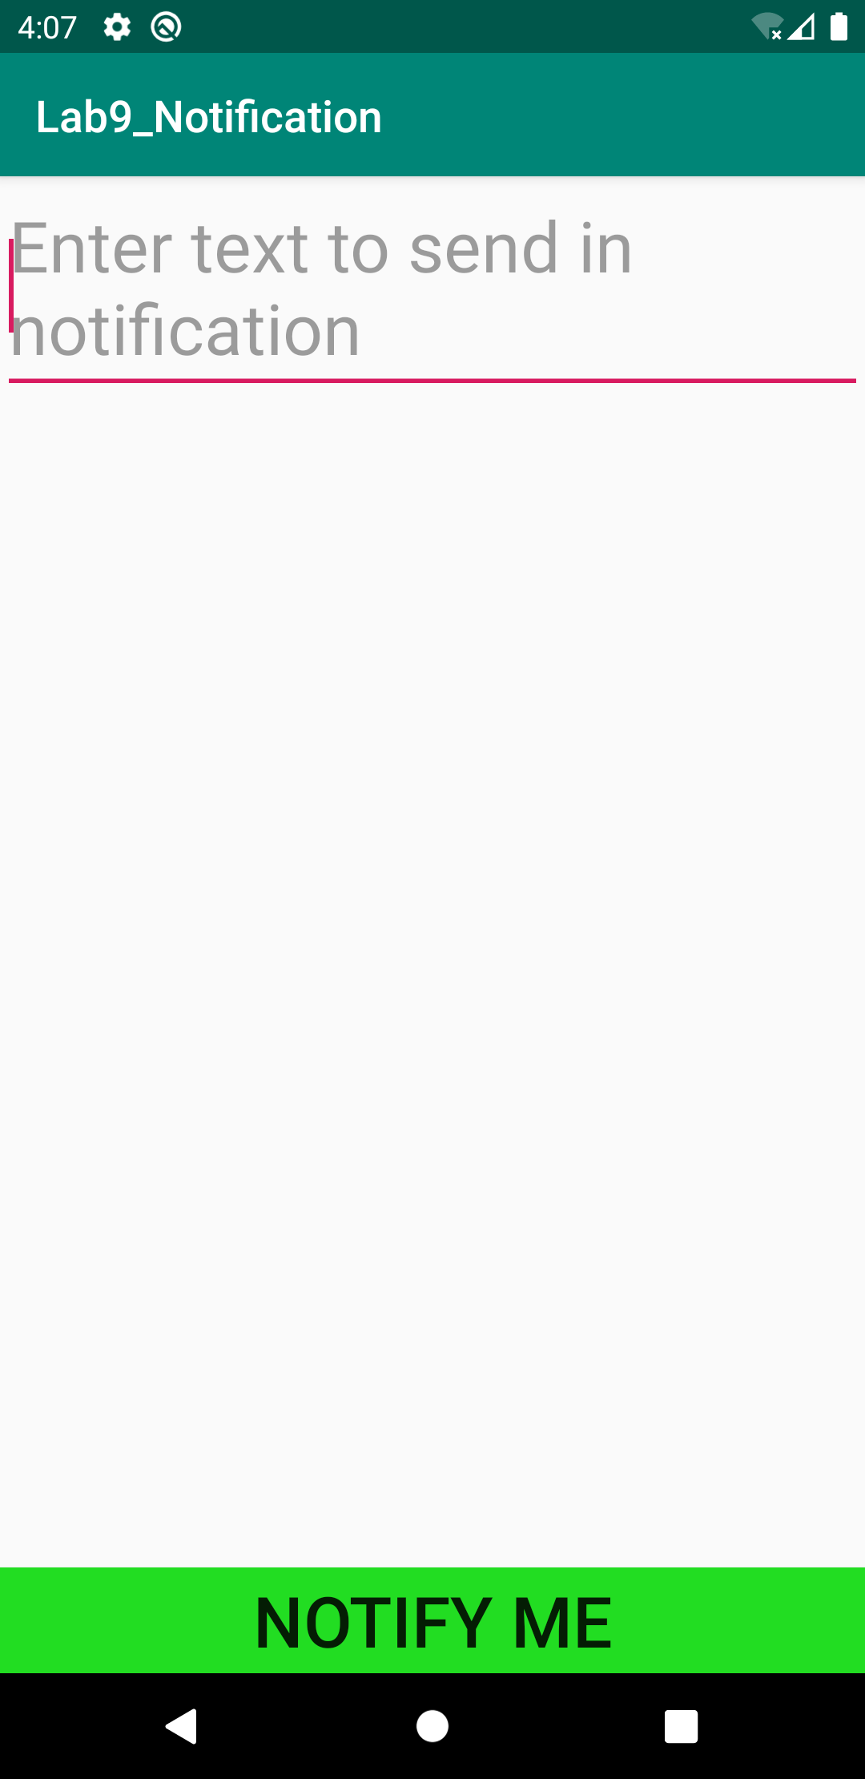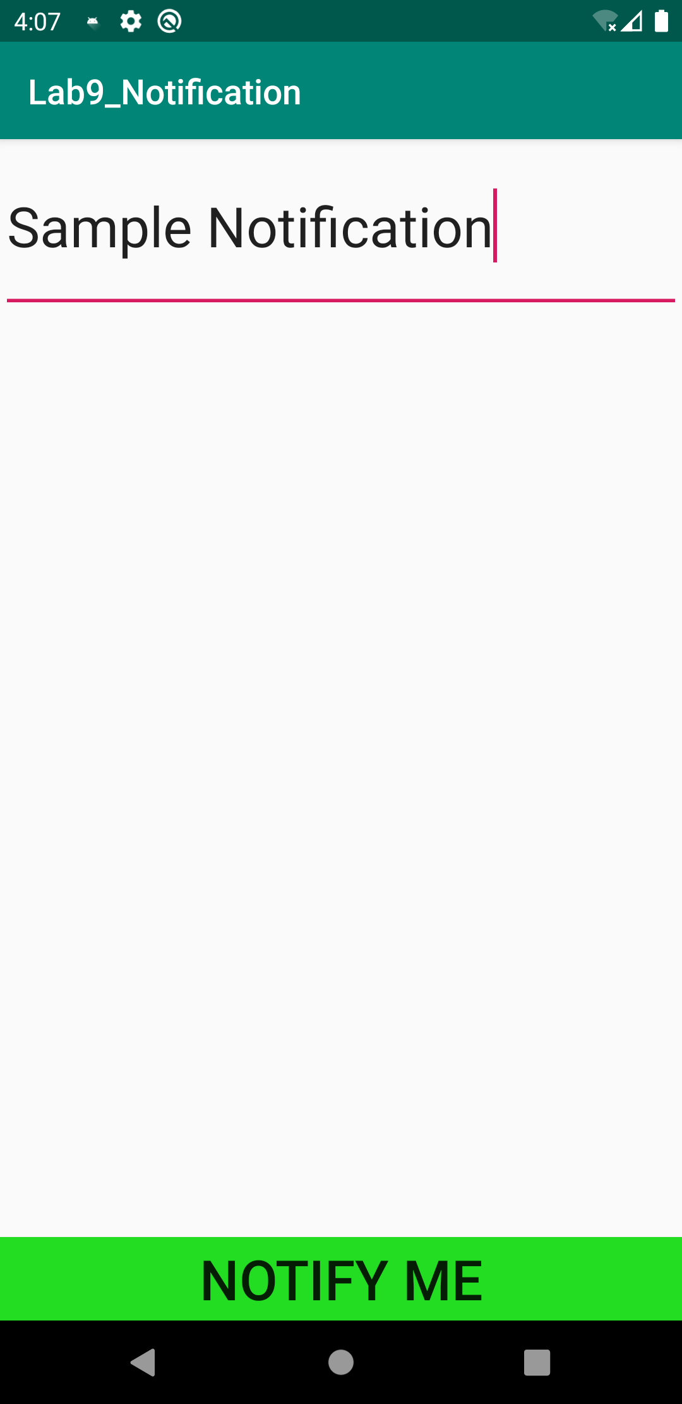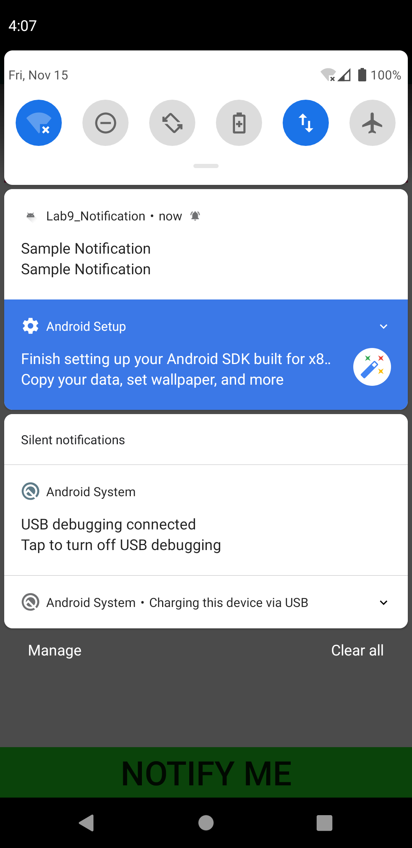**Output**